**HOUSING SERVICE WEB APPLICATION**

**Team name:** Tech Innovators

**Problem statement:** PS-2 Integrating common services

**Team leader:** Jenesha Malar S (22ADR043)

**Team members:** Lokitha R (22ADR058)

Aishwariya SK (22ADR002)

**University name:** Kongu Engineering College

**Mentor name:** Kayalvili S

**ABSTRACT**

This project proposes to create an Android or web application that will offer dependable and effective home repair services, such as carpentry, painting, plumbing, and electrical work. The program seeks to ensure high-quality service delivery and customer happiness by matching users with vetted specialists to handle common home difficulties. Users may rapidly locate workers in their area by using the location-based search option included in the program.

**INTRODUCTION**

Locating trustworthy and knowledgeable home service providers, such plumbers, carpenters, electricians, and painters, can be difficult in the fast-paced world of today. Finding reliable service providers who are available when required is a challenge that homeowners frequently encounter. Due to the lack of a unified platform, these services frequently result in disappointing service experiences due to time-consuming and ineffective search operations.

The creation of an application that meets the demands of consumers and service providers is included in the project's scope. The establishment of accounts, managing profiles, and location-based search are among the main features. The program will be made to function flawlessly on the web and Android platforms, guaranteeing wide use and accessibility.

The goal of the submitted proposal is to completely transform how housing services are obtained and provided. The program is expected to improve the efficiency, dependability, and transparency of housing services by offering a consolidated platform for both service providers and consumers. In addition to giving homes simple access to reliable experts, this will give service providers a stage on which to demonstrate their abilities and grow their clientele. In the end, the application hopes to raise the standard of housing services generally and support the development of a more structured and user-friendly service sector.

**LITERATURE SURVEY**

There are presently a number of platforms available to meet the need for trustworthy housing services. Among these, TaskRabbit, Urban Company, and Thumbtack are noteworthy. These platforms link consumers with nearby experts by offering a marketplace for a range of services. They have limits, but they have been successful in resolving some of the issues that homeowners encounter.

*TaskRabbit:* Mainly concentrates on a broad range of activities, ranging from little fixes to relocation assistance. It uses a strong system to screen Taskers (providers of services) and verifies quality using user feedback. But it doesn't have a distinct concentration on home services, which might reduce the amount of specialist knowledge available for jobs like electrical or plumbing repair.

*Urban Company:* Mostly located in urban regions, this company specializes in home services and beauty services. It prioritizes customer pleasure and provides experts with a thorough screening procedure. Despite its advantages, UrbanClap mostly serves large cities, underserving smaller towns and rural regions.

*Thumbtack:* Facilitates the search for experts in a range of services, encompassing home renovation. It offers a platform for thorough pricing estimates, customer evaluations, and service descriptions. One drawback is the wide range of services provided and the absence of a strict screening procedure, which leads to variations in service quality.

**SYSTEM DESIGN**

The system design focuses on building a web-based that connects public users with verified workers for various housing services.

**User Module**

The Public User module allows users to create an account, manage their profiles, and request services from nearby workers.

**Functionalities:**

* **Account Creation:**
  + Users can sign up using their name, mobile number, password, and address.
* **Profile Management:**
  + Users can update their personal information and address.
* **Service Request:**
  + Users can search for nearby workers based on the required service type.

**Worker Module**

The Worker module allows workers to create an account, update their profiles, and manage service requests.

**Functionalities:**

* **Account Creation:**
  + Workers can sign up using their worker ID, Aadhar ID, and address.
* **Profile Management:**
  + Workers can update their personal information, address, and worker type.

The provided ERD outlines the relationship between Public Users, Workers.

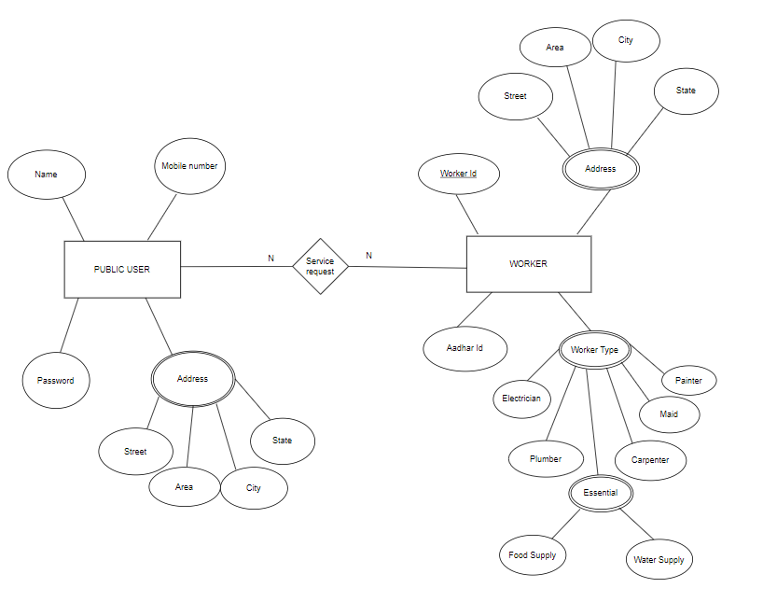

**IMPLEMENTATION**

* **Frontend:**
* React for building the user interface.
* CSS for styling the application.
* **Backend:**
* Node.js with Express.js for handling server-side logic.
* MongoDB for the database to store user and worker data.
* **Mobile Application:**
* React Native for building the Android application.

**CONCLUSION AND FUTURE WORK**

Future work includes:

1. **Booking System**: Implement a robust booking system that allows users to schedule appointments with service providers conveniently.
2. **Service Booking Tracking**: Provide real-time updates and notifications to users about the status of their bookings and service appointments.
3. **Worker Uploads**: Enable workers to upload photos or documentation of completed work. This can build trust and transparency with users.
4. **Machine Learning Recommendations**: Utilize machine learning algorithms to analyze user preferences and past reviews to provide personalized service recommendations.
5. **Review System**: Implement a review and rating system where users can provide feedback on the services they've received. Ensure these reviews are visible to other users to help them make informed decisions.
6. **User Interface**: Design an intuitive and user-friendly interface for both service providers and customers to enhance the overall user experience.
7. **Security and Privacy**: Ensure that all user data, including personal information and transaction details, are securely managed and protected.
8. **Scalability**: Plan for scalability from the beginning to accommodate future growth and increasing user demands.

In conclusion, the creation of an Android or web-based application targeted at resolving typical housing service demands has effectively closed the communication gap between service providers and customers. The software has shown to be successful in making necessary services like electricians, plumbers, carpenters, and painters more accessible, which has greatly increased users' convenience and productivity.